copper stamping sink
Product Introduction：
Copper stamping sink is an assembly of a base and a stamped fin which are soldered ,brazed or epoxied together. Copper stamping sink has good thermal performance due to it allows high-density fins and fin aspect ratios . and it is also has design flexibility , expecially with integrating heat pipes or ducting for fans or blowers.
Customers can chose base soldering with fin solution , or add heat pipe in design for higher performance request, and fans, blowers can provide much more thermal conductivity in cooling system applications.

Product Parameters:
Product Name | copper stamping sink
Material | copper
Surface treatment | Nickel Plated or Anti-oxidant
Process | Stamping,soldering,Brazing,epoxied
HeatPipes Quantity | 0-8 heat pipes, based on customer TDP required
Size： | Customized
Shape | Customized
Tolerance | ±0.1 or stricter
Application | Server cooling system ，computer CPU cooling  Medical equipment, Telecom Engineering,etc
Sample LT | 10-20days after payment in advance
Quality Contral | 100% thermal test for HP assembly,  and 100% visual check before shipping
Quality Guarantee | 2 years
Brand Name | Sinda Thermal
Certification | Rohs,SGS,GB/T19001-2016,ISO9001:2015
Place of Origin | DongGuan,Guangdong, China
Port | SHENZHEN,HONGKONG
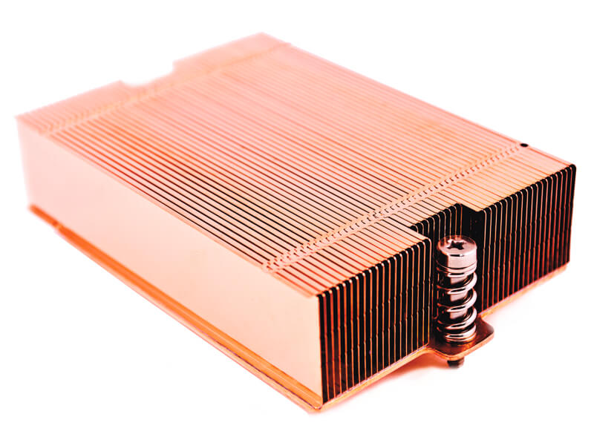
Detailed Images:
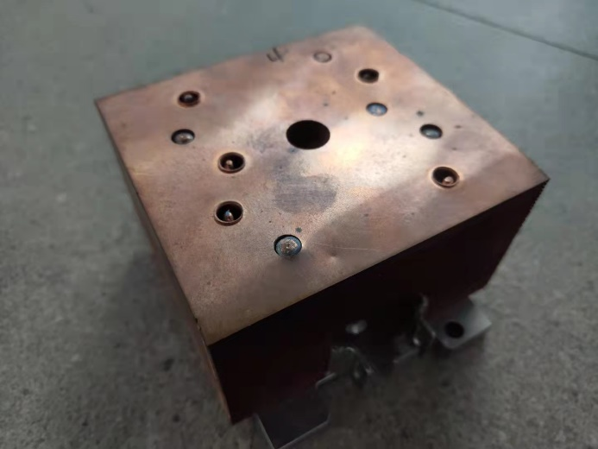
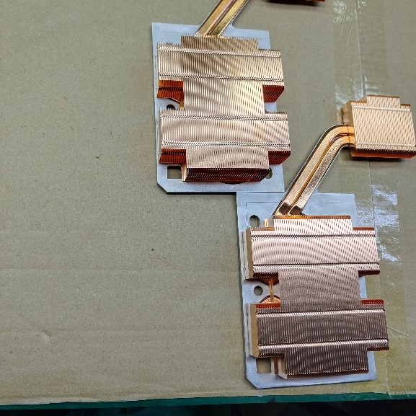
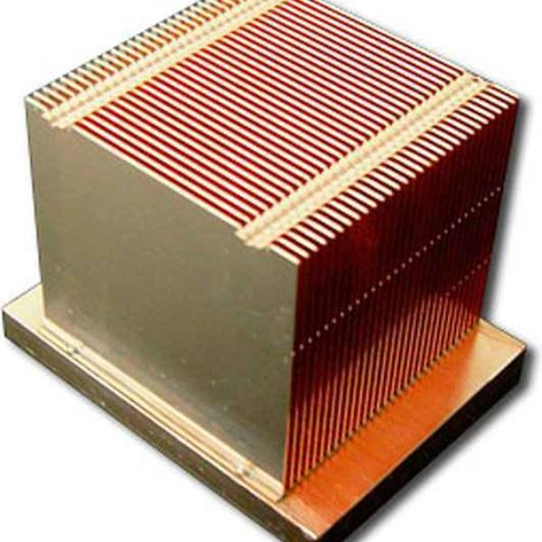
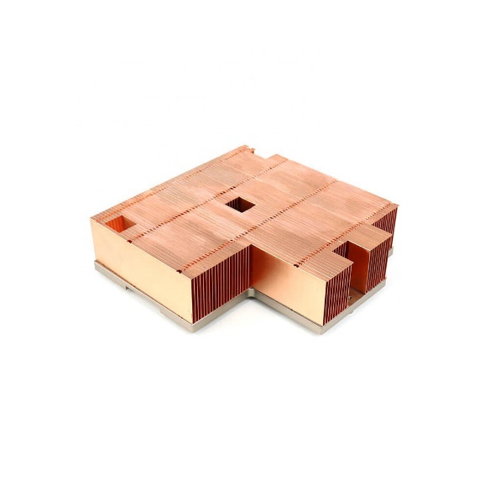

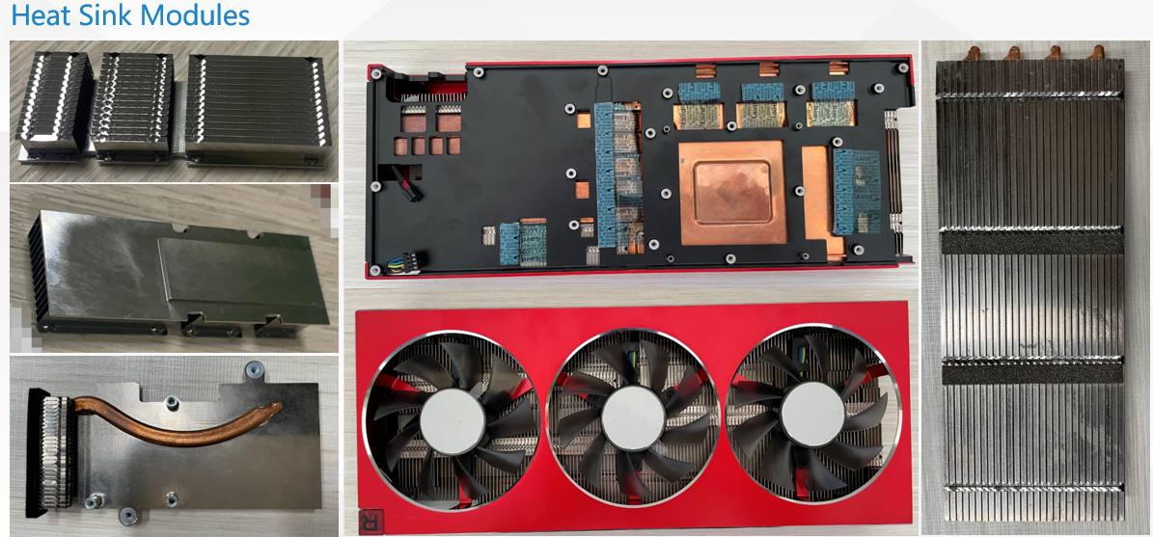
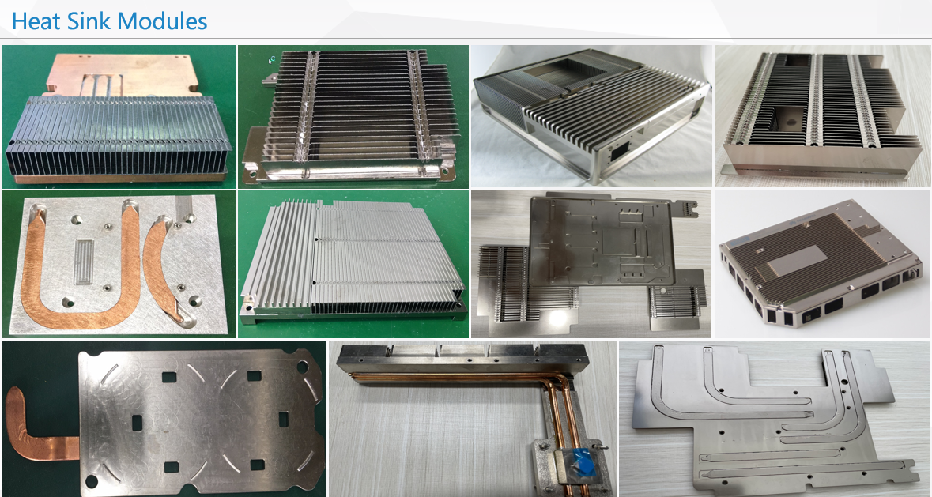
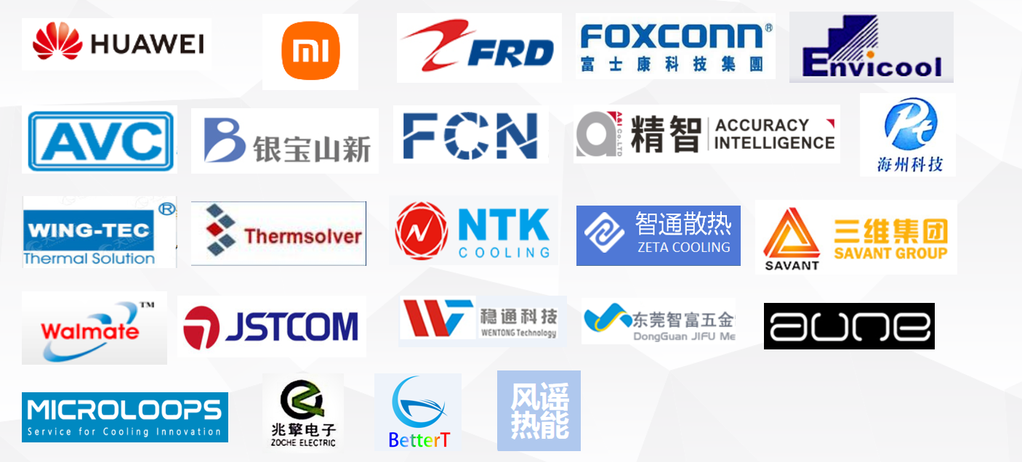
Our Customers & Products:
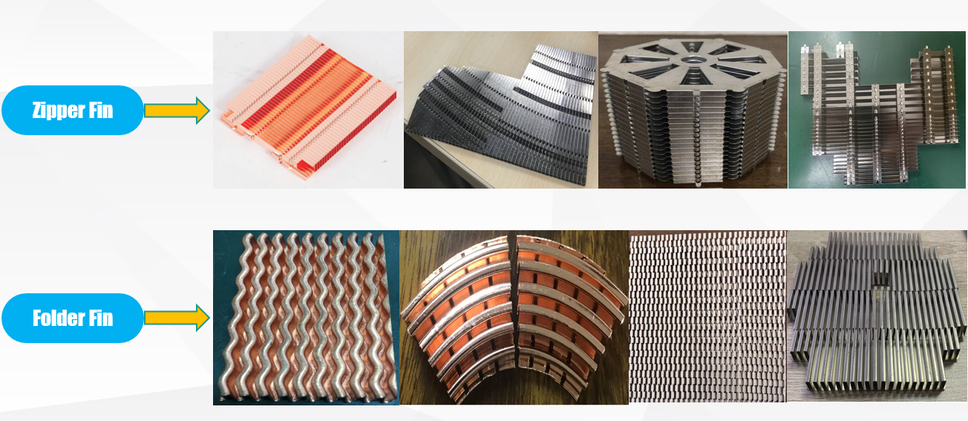
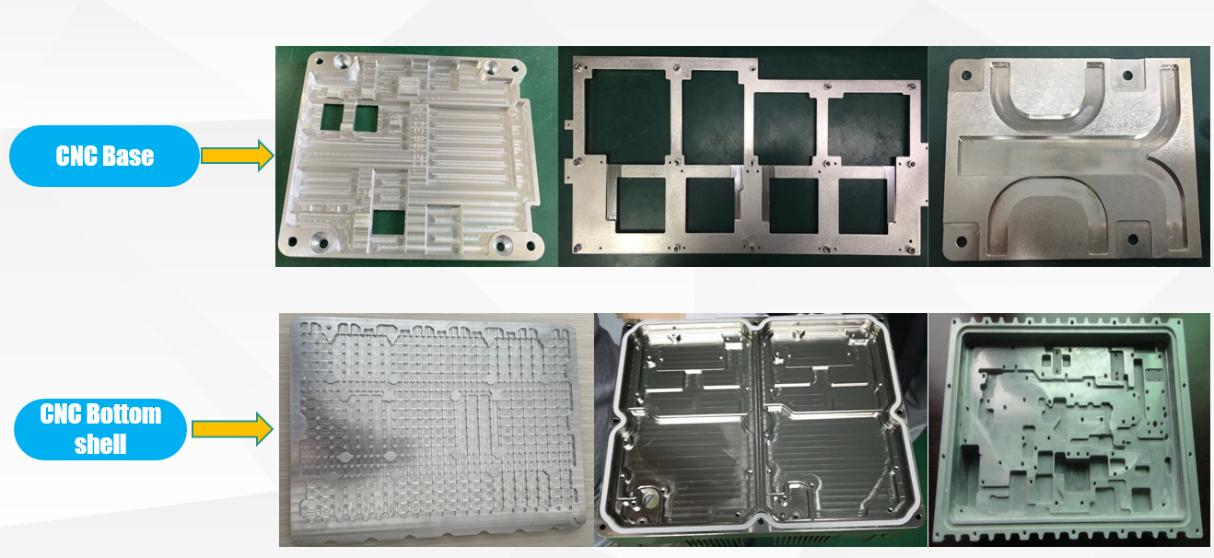
FAQ:
Q: How can I get the quotation?
A: Please send us your detailed information , 3D drawing and 2D drawing with notes will be great help , we will quote to you in 24 hours after information confirmed
Q: Is there any extra tooling cost for my product?
A: Usually, no tooling cost required for sample build; but for customized parts in mass production , tooling cost will be covered.
Q: What’s your shipping methods?
A: Customers can chose DHL, UPS, FedEx ,TNT ,EMS,etc as their prefer freight forwarder, normal freight term is FCA HK.

Q: What package do you use for shipment?
A: For heatsink modules, we usually use customized plastic tray and carton
as our mainly packages, customized service is also available.

